Prediction of Diseases using Different Machine Learning Approaches

**Abstract:**

The medical system is overworked and becoming more and more expensive in many countries each year as the number of patients and diseases rises. In order to be treated, the bulk of the ailment requires a visit to the doctor. A simple and affordable algorithm can predict diseases if there is enough data. A key part of treatment is the ability to diagnose disease based on symptoms. Using the patient's symptoms, we sought to accurately predict a disease in our project. We are going to use four different algorithms to accomplish this to obtain better accuracy. The use of such a technology in medical care in the future is quite promising. In order to facilitate interaction with the data, we are also planning to develop an interactive interface.

**Dataset:**

The dataset is an open-source one hosted in Kaggle Data Repository.

Total Rows : 4962 Total Diseases : 42

|  |
| --- |
| Fungal infection |
| Allergy |
| GERD |
| Chronic cholestasis |
| Drug Reaction |
| Peptic ulcer diseae |
| AIDS |
| Diabetes |
| Gastroenteritis |
| Bronchial Asthma |
| Hypertension |
| Migraine |
| Cervical spondylosis |
| Paralysis (brain hemorrhage) |
| Jaundice |
| Malaria |
| Chicken pox |
| Dengue |
| Typhoid |
| hepatitis A |
| Hepatitis B |
| Hepatitis C |
| Hepatitis D |
| Hepatitis E |
| Alcoholic hepatitis |
| Tuberculosis |
| Common Cold |
| Pneumonia |
| Dimorphic hemmorhoids(piles) |
| Heart attack |
| Varicose veins |
| Hypothyroidism |
| Hyperthyroidism |
| Hypoglycemia |
| Osteoarthristis |
| Arthritis |
| (vertigo) Paroymsal Positional Vertigo |
| Acne |
| Urinary tract infection |
| Psoriasis |
| Impetigo |

**Architectures planned to be used:**

* Decision Tree
* Random Forest
* K Nearest Neighbours
* Naïve Bayes Algorithm

**Flow of Project:**

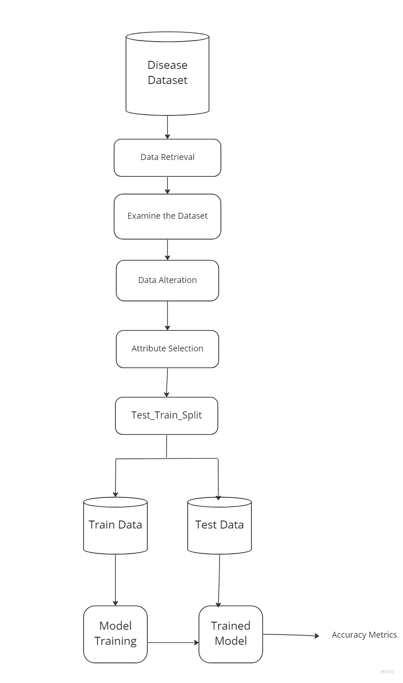

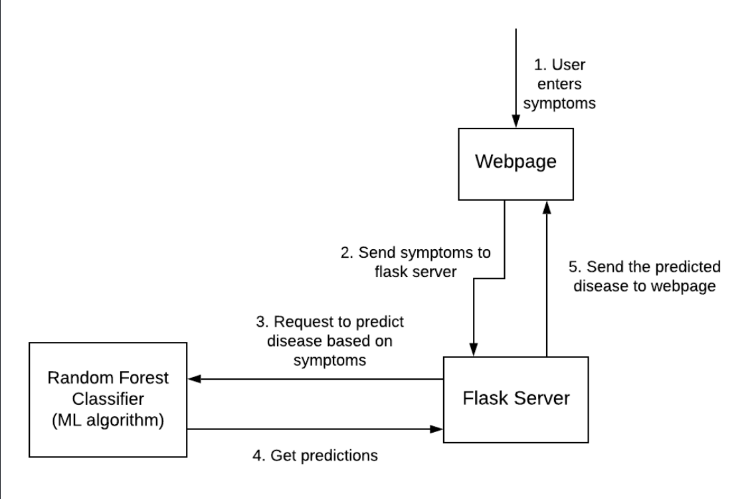

Trained Model